Randall C. Crawford
Student ID: 901012194
Email: r.crawford2194@student.nu.edu
Course: ANA 625 Categorical Data Methods
Homework 2

Case Study: SAS BRFSS 10 Categorical Table 2 and 3

This case study will continue your reintroduction to categorical variables and how you may use statistical procedures to investigate these types of data, display them in a “Table 2”, and develop a results section describing your Table 2.

This case study will also introduce you to adjusted analysis of categorical variables and how you may use statistical procedures to investigate these types of data, display them in a “Table 3”, and develop a results section describing your Table 3.

Continue using data from the Behavioral Risk Factor Surveillance System Survey from 2010 to complete this case study.

The objective of this analysis is to investigate the association between diabetes and BMI after controlling for exercise and sex. The outcome variable is DIABETES, and the variable of interest (exposure) is BMI.

Conduct a complete case, case control analysis for this objective following these guidelines:

- Use the raw variable _BMI4CAT and call it BMI
- Using the raw variable SEX, create a new two-level variable SEX (male=0, female=1) where male is category 1 of the raw variable and female is category 2
- Using the raw variable DIABETE2, create a new two-level variable DIABETES (no=0, yes=1) where yes is category 1 of the raw variable and no is category 3
- Using the raw variable EXERANY2, create a new two-level variable EXERCISE (no=0, yes=1) where yes is category 1 of the raw variable and no is category 2
- For the complete case analysis, restrict your sample based on the following conditions:
  - 18<=AGE<=99
  - SEX: raw categories 1 and 2
  - DIABETE2: raw categories 1 and 3
  - EXERANY2: raw categories 1 and 2
  - EDUCA: raw categories 1-6
  - _BMI4CAT: raw categories 1,2 and 3
  - GENHLTH: raw categories 1-5

All logistic regression models in this homework should be run using SAS PROC LOGISTIC. Use the DESCENDING option when not using a CLASS statement. Remember throughout that DIABETES should be coded as 1 = yes and 0 = no.

- (15 pts) Create your “Table 2” for this objective. You can use this table template:

Table 2. Characteristics of 413,748 BRFSS 2010 participants by presence of diabetes.
 | Sample Population |  | Diabetes - No |  | Diabetes - Yes
Variable | N | % | n | % | n | % | p value *
 | 413,748 | 100.00% | 360,098 | 87.03% | 53,650 | 12.97%
BMI
Normal | 145,352 | 35.13% | 137,163 | 38.09% | 8,189 | 15.26%
Overweight | 151,781 | 36.68% | 134,539 | 37.36% | 17,242 | 32.14%
Obese | 116,615 | 28.19% | 88,396 | 24.55% | 28,219 | 52.60% | <0.0001
Sex
Male | 162,430 | 39.26% | 139,820 | 38.83% | 22,610 | 42.14%
Female | 251,318 | 60.74% | 220,278 | 61.17% | 31,040 | 57.86% | <0.0001
Exercise
No | 111,531 | 26.96% | 89,873 | 24.96% | 21,658 | 40.37%
Yes | 302,217 | 73.04% | 270,225 | 75.04% | 31,992 | 59.63% | <0.0001
* p values based on Pearson chi-square test of association
**due to rounding, some % may not add up to 100%

- (20 pts) Write the results section for this “Table 2”. Use the “boilerplate” language shown in Case Study Example – Tables 1, 2 & 3.ppt exactly.

Of the 451,075 BRFSS 2010 participants, 413,748 (91.7%) had complete data for the objective. The demographic characteristics of this
sample population are compared in Table 2 with respect to the outcome variable, presence of diabetes. Overall, 13% of the entire sample
population had a diagnosis of diabetes. With regards to body mass index (BMI), there were notably more obese than expected who had
diabetes (52.6% vs 28.19%; p<0.0001), but there were relatively fewer overweight than expected who had diabetes (32.14% vs 36.68%). With
regards to sex, there were relatively fewer females than expected who had diabetes (57.86% vs 60.74%; p<0.0001). With regards to exercise,
there were notably fewer exercisers than expected who had diabetes (59.63% vs 73.04%; p<0.0001).

- (8 pts) Calculate the odds ratios (ORs) for a diagnosis of DIABETES using the data in Table 2. Fill in the table below with these ORs.
BMI (Normal) Odds = 8,189 / 137,163 = 0.0597 (Reference)
BMI (Overweight) Odds = 17,242 / 134,539 = 0.1282 OR = 0.1282 / 0.0597 = 2.147
BMI (Obese) Odds = 28,219 / 88,396 = 0.3192 OR = 0.3192 / 0.0597 = 5.347
SEX (Male) Odds = 22,610 / 139,820 = 0.1617 (Reference)
SEX (Female) Odds = 31,040 / 220,278 = 0.1409 OR = 0.1409 / 0.1617 = 0.871
EXERCISE (No) Odds = 21,658 / 89,873 = 0.2410 (Reference)
EXERCISE (Yes) Odds = 31,992 / 270,225 = 0.1184 OR = 0.1184 / 0.2410 = 0.491

 | OR
BMI
Normal | -----
Overweight | 2.147
Obese | 5.347
Sex
Male | -----
Female | 0.871
Exercise
No | -----
Yes | 0.491

- (28 pts) Consider the simple model DIABETES = f (BMI).

  - Create a binary variable OBESITY from BMI as follows:
- if BMI = 2,3 then OBESITY = 1; else OBESITY = 0

    - Run a logistic regression that estimates the model DIABETES = f (OBESITY). Use DESCENDING option without a CLASS statement. Show the Analysis of Maximum Likelihood Estimates (MLEs) output table.
proc logistic data=HW2 descending;
model diabetes = obesity; run;
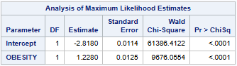

    - Show your hand calculation for the OR for a diagnosis of DIABETES with respect to OBESITY using the data shown in the MLEs table.
OR = exp(1.228) = 3.414

    - Interpret the magnitude of your calculated OR.
The odds of a diabetes diagnosis from obesity are 3.4x greater relative to no obesity.

    - Show your hand calculation for the global chi-squared test statistic. Interpret your calculated value.

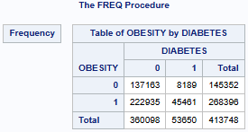
p(OBESITY=0) => 145,352 / 413,748 = 0.3513
p(OBESITY=1) => 268,396 / 413,748 = 0.6487
p(DIABETES=0) => 360,098 / 413,748 = 0.8703
p(DIABETES=1) => 53,650 / 413,748 = 0.1297
Using p(OBESITY & DIABETES) identification: Estimated ((Estimated - Actual)^2) / Estimated = Result
p(0 & 0) => 0.3513 x 0.8703 = 0.3057 126,482.76 ((126,482.76 - 137,163)^2) / 126,482.76 = 901.84
p(0 & 1) => 0.3513 x 0.1297 = 0.0456 18,866.91 ((18,866.91 - 8,189)^2) / 18,866.91 = 6,043.27
p(1 & 0) => 0.6487 x 0.8703 = 0.5646 233,602.12 ((233,602.12 - 222,935)^2) / 233,602.12 = 487.10
p(1 & 1) => 0.6487 x 0.1297 = 0.0841 34,796.21 ((34,796.21 - 45,461)^2) / 34,796.21 = 3,268.68
Totals: 1.0000 413,748.00 10,700.89
Pearson's Chi-Square (X2): 10,700.89 > 3.841 Chi-Square Critical Value (a = 0.05 and dof = 1)
Given the Pearson's Chi-Square (X2) of 10,700.89 is greater than the critical Chi-Square value of 3.841, the null hypothesis (H0) is
rejected in favor of a statistical association between the OBESITY and DIABETES variables.

  - Now, run a logistic regression that estimates the model DIABETES = f(BMI). Use DESCENDING option without a CLASS statement.
proc logistic data=HW2 descending;
model diabetes = bmi; run;

    - Show the MLEs output table.

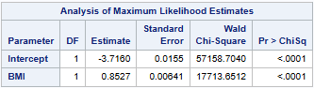

    - Show your hand calculation for the OR for a diagnosis of DIABETES with respect to BMI using the data shown in the MLEs table.
OR = exp(0.8527) = 2.346

    - Interpret the magnitude of your calculated OR.
The odds of a diabetes diagnosis from body mass index (BMI) are 2.35x greater relative to not being from body mass index (BMI).

    - Why does this OR differ from the OR you calculated in part (a)?
The BMI OR looked at the variable in its totality, while the OBESITY OR focused on the Overweight and Obese that have a greater occurrence of having diabetes in their subgroup.

  - Now, run a logistic regression that estimates the model DIABETES = f(BMI) with a CLASS statement using DIABETES = 0 and BMI = 1 as the reference categories and PARAM = ref.
proc logistic data=HW2;
class diabetes (ref='0') bmi (ref='1')
/ param=ref;
model diabetes = bmi; run;

    - Show the MLEs output table.

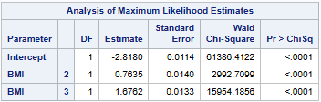

    - Show your hand calculation for the OR for a diagnosis of DIABETES with respect to the two levels of BMI, 2 and 3, using the data shown in the MLEs table.
OR(BMI=2) = exp(0.7635) = 2.146
OR(BMI=3) = exp(1.6762) = 5.345

    - Interpret the magnitude of each of your calculated ORs.
The odds of a diabetes diagnosis from being overweight (BMI=2) are 2.15x greater relative to being normal (BMI=1).
The odds of a diabetes diagnosis from being obese (BMI=3) are 5.35x greater relative to being normal (BMI=1).

  - Finally, create two dummy variables as follows:
- If BMI = 2 then BMI_OVERWEIGHT = 1; else BMI_OVERWEIGHT = 0.
- If BMI = 3 then BMI_OBESE = 1; else BMI_OBESE = 0.

    - Run a logistic regression that estimates the model DIABETES = f (BMI_OVERWEIGHT, BMI_OBESE). Use DESCENDING option without a CLASS statement. Show the MLEs output table.
proc logistic data=HW2 descending;
model diabetes = bmi_overweight bmi_obese; run;

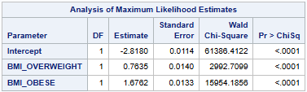

    - Show your hand calculation for the OR for a diagnosis of DIABETES with respect to BMI_OVERWEIGHT and BMI_OBESE using the data shown in the MLEs table.
OR(BMI_OVERWEIGHT) = exp(0.7635) = 2.146
OR(BMI_OBESE) = exp(1.6762) = 5.345

    - Why are these ORs the same as the ones calculated in part (c) above?
The created dummy variables have the same number of affirming responses as their corresponding BMI value.

- (46 pts) Consider the expanded model DIABETES = f (BMI, SEX, EXERCISE).

- Run a logistic regression that estimates the model DIABETES = f (BMI, EXERCISE, SEX), with a CLASS statement which specifies these reference categories: DIABETES = 0; EXERCISE = 0; SEX = 0; BMI = 1. Also use PARAM = ref.
proc logistic data=HW2;
class diabetes (ref='0') exercise (ref='0') sex (ref='0')
bmi (ref='1') / param=ref;
model diabetes = bmi exercise sex; run;

    - Show the Analysis of Maximum Likelihood Estimates (MLEs) output table.

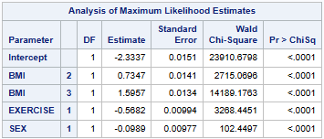

    - Interpret both the sign and magnitude of the estimated coefficient for EXERCISE.
An exerciser (EXERCISE=1) has a 0.5682 decrease in the estimated log odds of DIABETES, controlling for BMI and SEX.

    - Show your hand calculation for the OR for a diagnosis of DIABETES with respect to EXERCISE using the data shown in the MLEs table.
OR(EXERCISE=1 vs 0) = exp(-0.5682) = 0.567

    - Interpret both the sign and magnitude of the estimated odds ratio for EXERCISE.
An exerciser is 0.567 times as likely to have diabetes (42.3% lesser odds) than a non-exerciser, controlling for BMI and SEX.

- Run a logistic regression that estimates the following 2 models with the CLASS statement in 5(a) using PARAM=ref:
- DIABETES = f (BMI, EXERCISE, SEX)
- DIABETES = f (BMI, EXERCISE)

    - Show the MLEs output table for each estimated model.

DIABETES = f(BMI, EXERCISE, SEX)
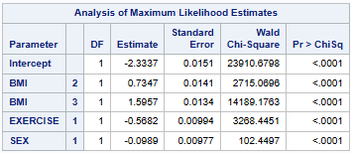

DIABETES = f(BMI, EXERCISE)
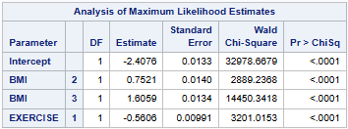

    - Based on the estimated models’ AIC, which model is “better”? Explain. Support your answer with the relevant statistical output tables.

DIABETES = f(BMI, EXERCISE, SEX) DIABETES = f(BMI, EXERCISE)
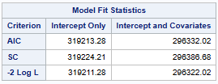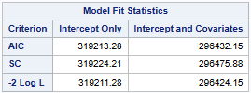
Based the AIC statistic, the DIABETES = f(BMI, EXERCISE, SEX) model is better, because the model’s score of 296,322.02 is less than the score of 296,432.15 from the DIABETES = f(BMI, EXERCISE) model.

    - Produce a single chart which shows the ROC for each model.

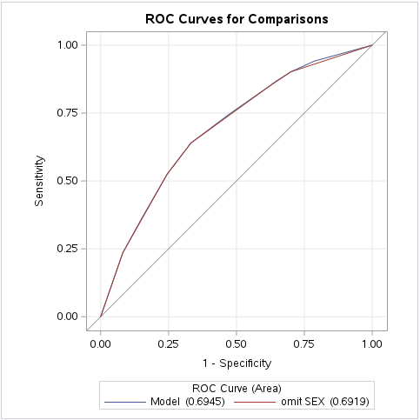
    - Based only on the overlaid plot of the two model’s ROC in part 5(b)(iii), which model is better? Explain, ignoring the shown AUC statistics in your answer.
Both ROC curves for the models almost match up perfectly with the slight exception of DIABETES = f(BMI, EXERCISE, SEX), which is better, due to a divergence beginning at approximately 0.70 Specificity and 0.90 Sensitivity to probably 0.99 Specificity and Sensitivity. This provides slightly more area under the curve than the DIABETES = f(BMI, EXERCISE) model.

- For the estimated model (with the CLASS statement used in part 5(a)) DIABETES = f (BMI, EXERCISE, SEX), consider the deviance chi-squared test:

    - What question is the test attempting to answer?
The goodness of fit (GOF) deviance chi-squared test evaluates whether or not an unsaturated model is fitting better than a saturated model.

    - What is the null hypothesis H₀ of the test?
The null hypothesis H0 is that the current unsaturated model is fitting better than a saturated model.

    - What does the test statistic show in this case and what should we do? Support your answer with the relevant SAS output table from the above estimated regression.

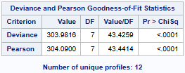

The p-value for deviance of <0.0001 is less than the alpha standard of 0.05 indicating that the H0 of the current unsaturated model fitting better than a saturated model can be rejected. So, we should investigate potential interactions.
- For the estimated model (with the CLASS statement used in part 5(a)) DIABETES = f (BMI, EXERCISE, SEX):

    - Create a cross-tabulation table showing predicted vs actual values for DIABETES using a cutoff value of probability (DIABETES) >= 0.20.

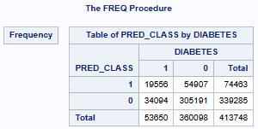

    - Show your hand calculation for the associated sensitivity and specificity values for a cutoff value of >= 0.20.
Sensitivity p(prediction = yes|actual = yes) = 19,556 / 53,650 = 0.365 = 36.5%
Specificity p(prediction = no|actual = no) = 305,191 / 360,098 = 0.8475 = 84.75%

    - If the model is to be used to predict diabetes and the goal is to minimize false negatives (predicting no diabetes when diabetes is present), then which is more important: sensitivity or specificity? Explain.
Sensitivity would be more important, given a higher percentage would serve to minimize false negatives.

    - Based on your answer to 5(d)(iii), to classify DIABETES (yes/no) based on the predicted probabilities, should a higher or lower cut-off value be used? Explain.
A lower cut-off value should be potentially used, given that reducing the cutoff value increases sensitivity and reduces specificity.

- Compare the unadjusted OR calculated in Question 3 and the adjusted OR from the estimated regression in part 5(a) above:

    - Fill in the table below with these odds ratios
 | Unadjusted OR | Adjusted OR
BMI
Normal | ----- | -----
Overweight | 2.147 | 2.085
Obese | 5.347 | 4.932
Sex
Male | ----- | -----
Female | 0.871 | 0.906
Exercise
No | ----- | -----
Yes | 0.491 | 0.567

    - In what sense are the ORs obtained from the logistic regression “adjusted”? Does this account for the differences between the unadjusted and adjusted ORs? Explain.
Odds ratios (ORs) from logistic regression account for the presence of covariates. Yes, the odds ratios (ORS) were calculated individually from contigency table 2 for each variable without the influence of the other covariates.

- (12 pts) Create your “Table 3” for this objective using your regression results from Question 5(a) above. You can use this table template:
Table 3. Logistic regression analysis comparing the adjusted odds ratio of diabetes in 413,748 BRFSS 2010 participants.
 | Diabetes - No |  | Diabetes - Yes |  | OR* | 95% CI
Variable | n | % | n | %
 | 360,098 | 87.03% | 53,650 | 12.97% | ----- | -----
BMI
Normal | 137,163 | 38.09% | 8,189 | 15.26% | ----- | -----
Overweight | 134,539 | 37.36% | 17,242 | 32.14% | 2.085 | 2.028 - 2.143
Obese | 88,396 | 24.55% | 28,219 | 52.60% | 4.932 | 4.804 - 5.063
Sex
Male | 139,820 | 38.83% | 22,610 | 42.14% | ----- | -----
Female | 220,278 | 61.17% | 31,040 | 57.86% | 0.906 | 0.889 - 0.923
Exercise
No | 89,873 | 24.96% | 21,658 | 40.37% | ----- | -----
Yes | 270,225 | 75.04% | 31,992 | 59.63% | 0.567 | 0.556 - 0.578
* 95% confidence intervals are for reported odds ratios.
**due to rounding, some % may not add up to 100%

- (21 pts) Write the Table 3 results section/interpretation. Use the “boilerplate” language shown in Case Study Example – Tables 1, 2 & 3.ppt exactly.
Adjusted odds ratios from the logistic regression are presented in Table 3. Those who reported exercising had roughly half the odds (43.3% lower) of reporting diabetes when compared to those not exercising after controlling for BMI and sex (OR=0.567; 95% CI = 0.556-0.578). Females were at slightly lower odds (9.4% lower) of reporting diabetes when compared to males after controlling for BMI and exercise (OR=0.906; 95% CI = 0.889-0.923). With respect to the exposure variable BMI, those who were obese had substantially greater odds (4.9 times or 393.2% higher) of reporting diabetes as compared to those who were normal after controlling for sex and exercise (OR=4.932; 95% CI = 4.804-5.063). Those who were overweight had higher odds (2.1 times or 108.5% higher) of reporting diabetes as compared with those who were normal after controlling for sex and exercise (OR=2.085; 95% CI = 2.028-2.143).

Extra Credit (10 pts)
Returning to our base logistic regression model for Table 3, DIABETES = f (BMI, EXERCISE, SEX), rerun the model using a CLASS statement which specifies these reference categories: DIABETES = 0; EXERCISE = 0; SEX = 0; BMI = 1. Also use PARAM = ref.
proc logistic data=HW2;
class diabetes (ref='0') exercise (ref='0') sex (ref='0')
bmi (ref='1') / param=ref;
model diabetes = bmi exercise sex; run;

- Show your hand calculation for the Deviance statistic for this model. Show the relevant SAS output tables you need for this calculation. Interpret your calculated value.

Current Model
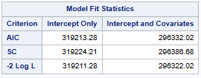
Saturated Model
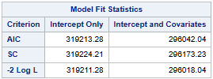
-2 Log L for the DIABETES = f(BMI, EXERCISE, SEX) current model = 296,322.02
-2 Log L for the DIABETES = f(BMI, EXERCISE, SEX, BMI*EXERCISE, BMI*SEX, EXERCISE*SEX, BMI*EXERCISE*SEX) saturated model = 296,018.04
The deviance statistic = 296,322.02 - 296,018.04 = 303.98

- Show the MLE for the fully saturated model.
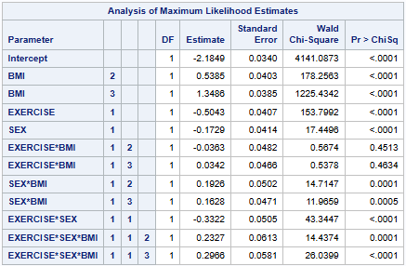
- Show the deviance output table for the fully saturated model. Does the estimated deviance statistic make sense? Explain.
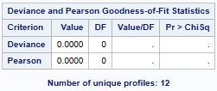
Given that two interactions have p-values greater than the 0.05 alpha standard, the deviance statistic of zero makes sense, because all interaction Beta coefficients must be statistically different from 0 to generate a proper statistic.

- Identify which interactions should be removed, if any.
EXERCISE*BMI(BMI=2) and EXERCISE*BMI(BMI=3) should be removed.

- Estimate the final model and show the MLE table.
DIABETES = f(BMI, EXERCISE, SEX, BMI*SEX, EXERCISE*SEX, BMI*EXERCISE*SEX)
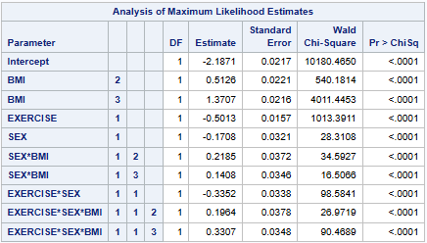

- Show the final model deviance output table. Explain what the deviance statistic now shows and whether it makes sense.

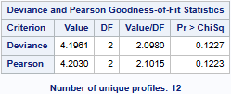
The final model deviance statistic is 4.1961, and the p-value of 0.1227 that is greater than the 0.05 alpha standard indicates that the H0 of the final model fitting better than a saturated model cannot be rejected. So, there is no further need to investigate interaction.

